Game Rental System – ASP.Net

# **Login Page:**

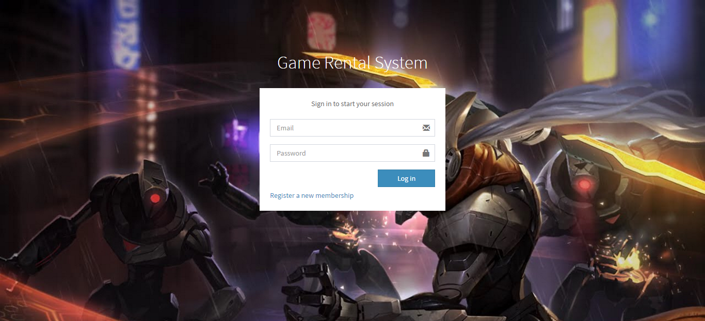

In this page, when user enters email and password and click on ‘Login’, both fields data are get from the fields and an AJAX call is send to database through Javascript that checks the validation of credentials, if that call return true, it will be redirect to motel page and in the case of false return, the message is shown through Jquery function.

# **Signup/Register Page:**

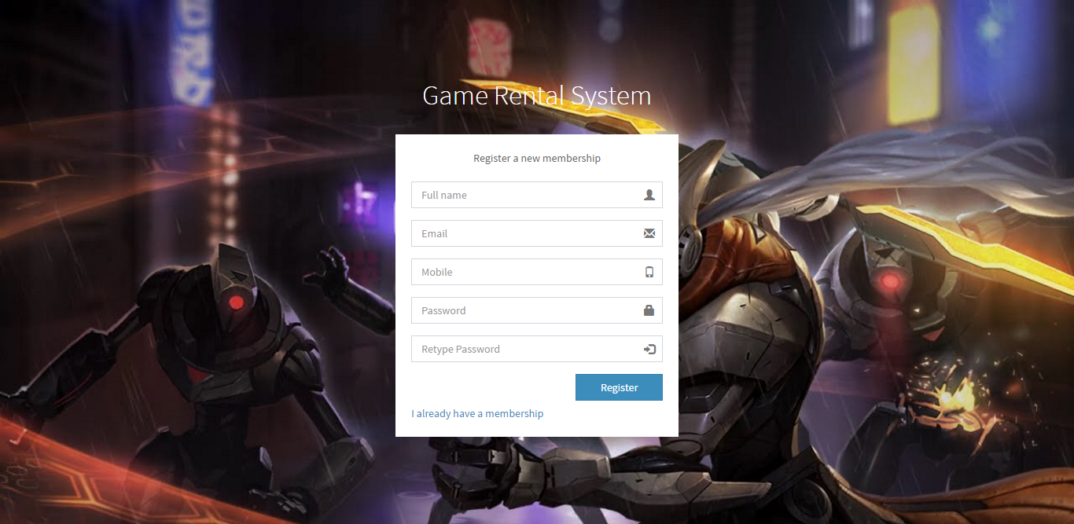

While register the user, we take full name (that can be any), email (email is validated here with Jquery validator), mobile number and passwords and when clicking on “Register”, this all data is taken to database via Javascript and response will tell that account is created and all data is stored in the database.

# **Games List Page:**

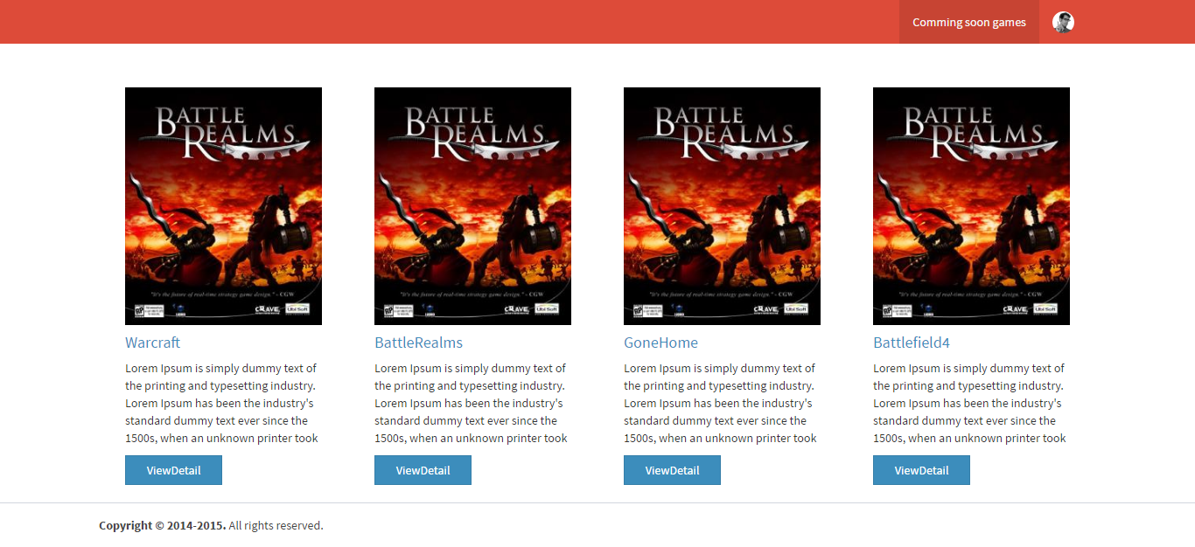

This page shows games that are stored in database. The data is populated by pulling itself from the database. All coming soon data request is sent to database and the query pulls record from the database.